**Form Proposal**

**Mood Board**

The important characteristics for this device are how the melody will be heard by the singer and the harmony heard by the device, the way the desired notes will be displayed, how feedback will be given on the harmony being sung, and the way the device will be held or attached to the user.























**Aesthetic Concepts**

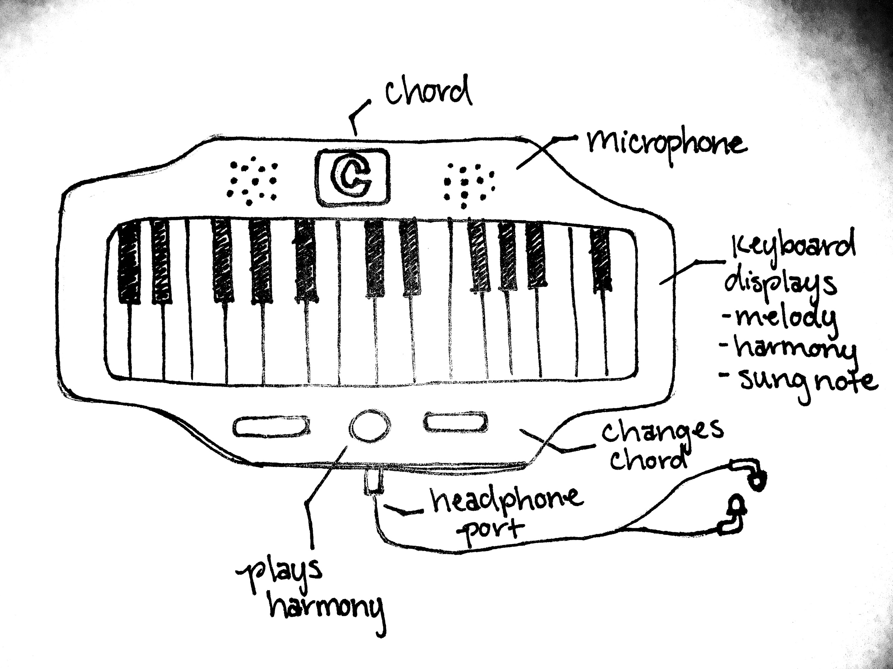

*Concept 1*

Keyboard Harmonizer – This device allows user to hear a note through their headphones and attempt to harmonize using a suggested chord formation. The keys change color and indicate which note is the melody, which note is the harmony, and the note that you are singing. The piano approach helps users develop a spatial understanding for chords as well as give feedback on whether they are in tune or not.

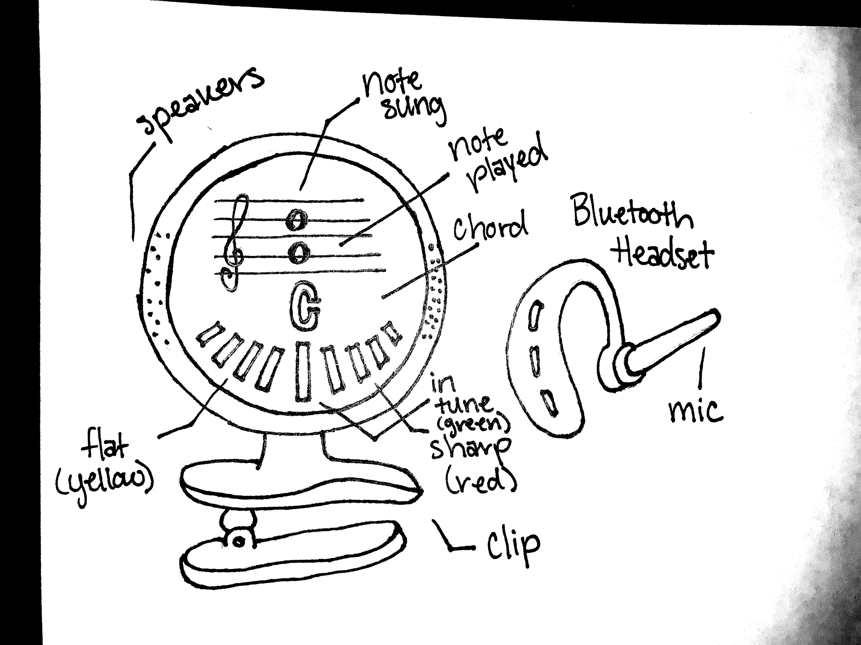

*Concept 2*

Car Harmonizer – The car harmonizer allows user to practice harmonizing while driving. It utilizes a Bluetooth headset to pick up on the users singing and rates how in tune the note is with the gradual bars, with left being flat and right being sharp. The melodic note and the upper harmonic note are displayed on a musical staff with the chord name below it. It also features a clip that can attach to most ledges. This design allows drivers to hear the melodic note without the use of headphones and prevents the device from hearing itself by having the microphone on the Bluetooth headset.

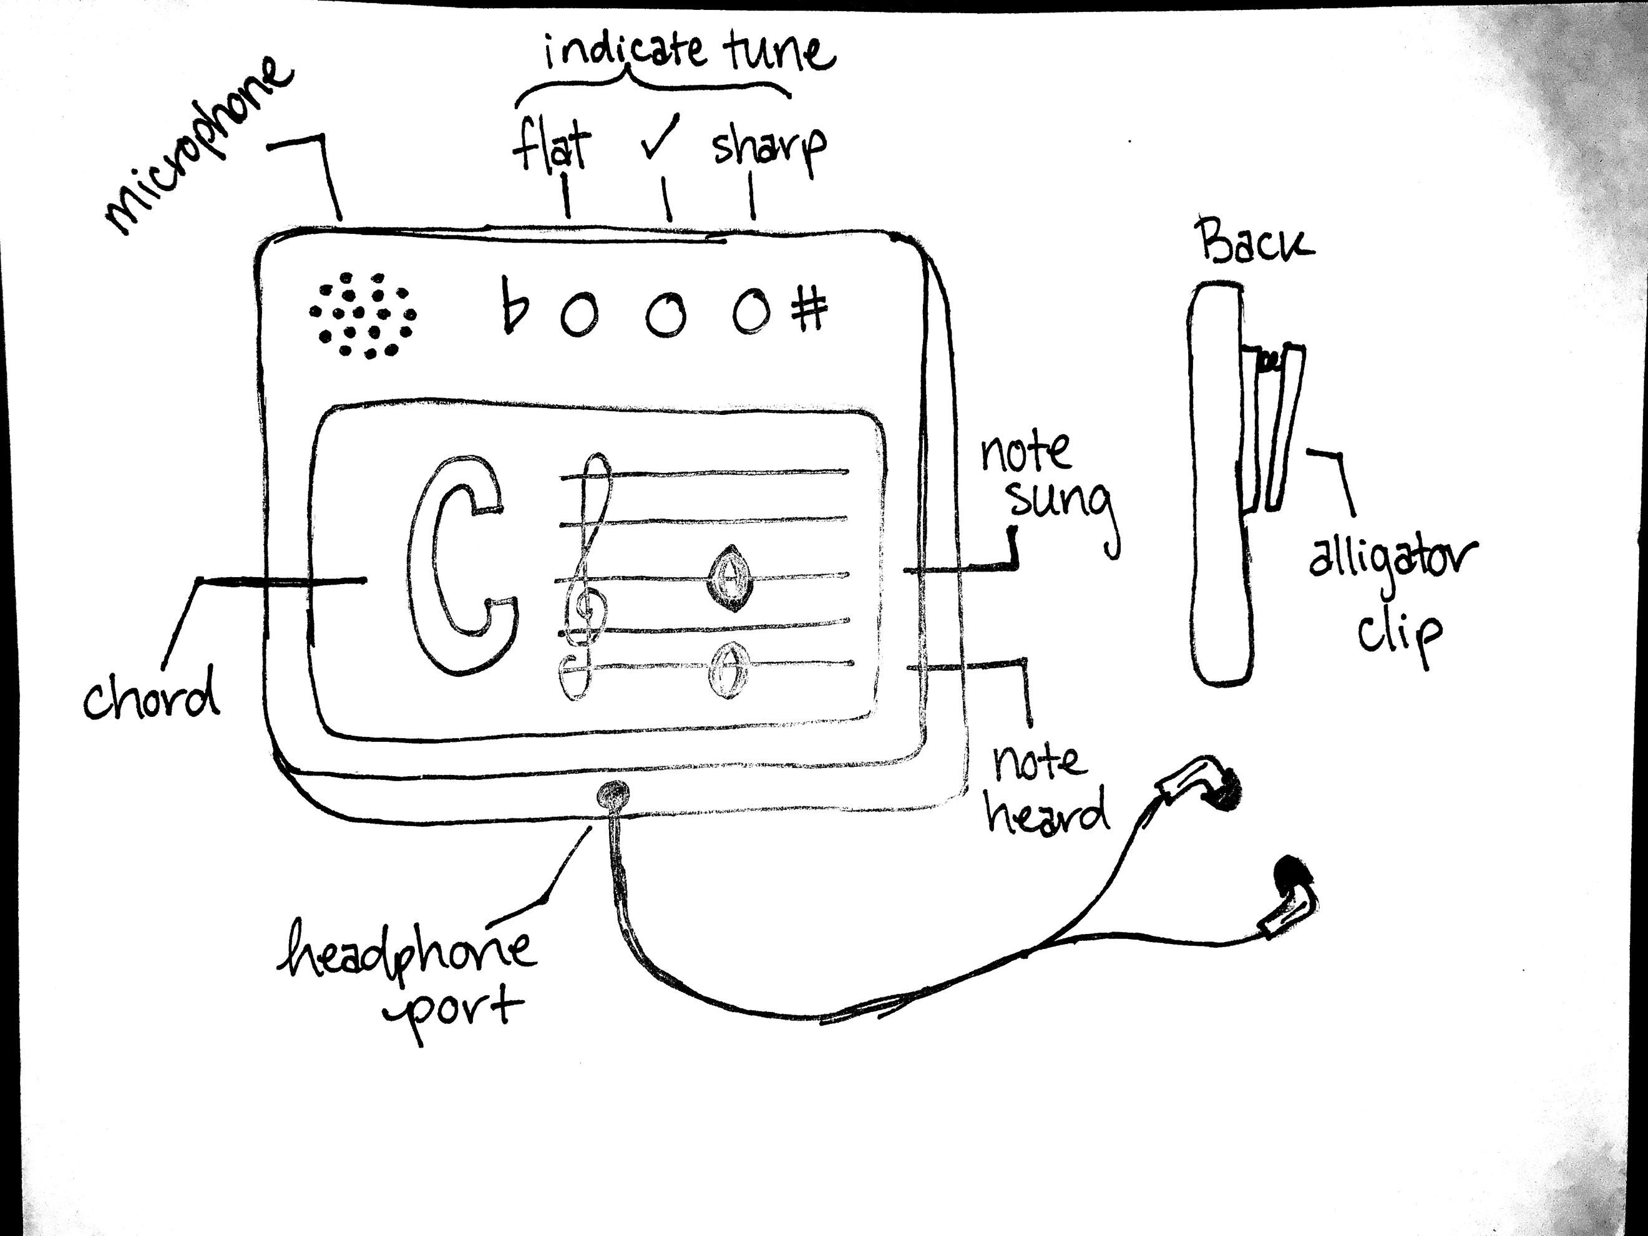

*Concept 3*

Pager Harmonizer – This design utilizes headphones for the melodic note and a screen display to communicate what note is being played, what note it wants to hear, and the chord this harmony comes from. There are 3 LEDs at the top, the left one glows red if you are flat, the center one green if you are in tune, and the right one yellow if you are sharp. It has a clip on the back making it easy to attach to sheet music or other surfaces. This style of tuning is familiar to most musicians and the staff is a universal way of communicating notes.

Concept Summary - Summarize the strengths and weaknesses of each design. Write a short description of the features your proposed device will have based on this analysis.

**Concept Summary**

Concept 1 was pleasing ergonomically. It has natural holds on the side mimicking the shape of old Gameboys. It also features a center button that allows the user to hear the harmony with the melody before they attempt to sing it which could be very helpful for someone new to sight reading notes. The other buttons could be used to navigate between different modes on the device. The flaws in this design are that headphones are required, the multiple lit up keys could be potentially confusing, and it is not hands-free.

Concept 2 provides great solutions for how to practice harmonizing in the car with its clip feature and use of Bluetooth headsets. It has a compact design which is perfect for using it on the go, but it also makes the screen feel a bit small and crowded. There are a lot of visual components which might prove distracting to a driver so that is another design issue to be considered.

Concept 3 is very straightforward and allows for a larger display of information. It utilizes familiar concepts like the LEDs at the top and the music staff which makes it more intuitive for users. It’s shortcoming is that it is not able to tell you which note you are singing, only that it is more flat than the note it is looking for. It also lacks buttons for potentially changing modes.

Based on this analysis, I want my final device to feature a clip, a button that allows the user to hear a sample of the harmony, the LED indicators for tune, the staff to display the notes, and the Bluetooth headset system.